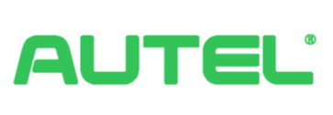**Autel New Energy Co.,Ltd**  
Room 101, Building B2, Zhiyuan, No.1001 Xueyuan Avenue, Changyuan Community, Taoyuan Road, Nanshan District, Shenzhen, 518055,China.   
**Email:** [support.eu@autel.com](mailto:support.eu@autel.com) **Tel:** +49 (0) 89 540299608 (Europe)

**EC DECLARATION OF CONFORMITY  
Reference no.: ATL2022CE0020001**

Applicant: **Autel New Energy Co.,Ltd**  
Room 101, Building B2, Zhiyuan, No.1001 Xueyuan Avenue, Changyuan Community, Taoyuan Road, Nanshan District, Shenzhen, 518055,China.  
Manufacturer: **Autel New Energy Co.,Ltd**  
Room 101, Building B2, Zhiyuan, No.1001 Xueyuan Avenue, Changyuan Community, Taoyuan Road, Nanshan District, Shenzhen, 518055,China.

Product: **AC Electric Vehicle Charging Station**  
Model(s): **Maxi U W - XX - YY – L – M - ZZ**

"U" denotes for basic model designation, "U" can be:

EU AC series /EU1 AC series/C-SE AC series/C-SE1 AC series

“W” denotes for power: W7/W11/W22

“XX” denotes for vehicle connection method: BC3/BC5/BC7/C3/C5/C7/S/H

“YY” denotes for wireless function: 4G/Blank  
 “L” denotes for LCD panel function  
 “M” denotes for MID function

“ZZ” denotes for color: B/DG/WH/RG/SV  
This product has been tested by us according to the following standards:

1. LVD Test Standards: EN IEC 61851-1:2019
2. RED(EMC) Test Standards:   
   EN 300 328 V2.2.2:2019/ EN 300 330 V2.1.1:2017/ EN 301 908-1/-13 V13.1.1:2019  
   EN 301 908-2 V13.1.1:2020/ EN 301 511 V12.5.1:2017/ EN 50663:2017/ EN 50665:2017/ EN 301 489-1 V2.2.3:2019/ EN 301 489-3 V2.1.1:2019  
   EN 301 489-17 V3.2.4:2020/EN 301 489-52 V2.1.1:2019  
   IEC 61851-21-2:2018/ EN IEC 61851-21-2:2021/ EN IEC 61851-1:2019
3. RoHS Concerning standards:  
   EN 62321-1:2013/ EN 62321-2:2014/ EN 62321-3-1:2014/ EN62321-4:2014/ EN 62321-5:2014/ EN 62321-6:2015/ EN 62321-7-1:2015/ EN 62321-7-2:2017/ EN 62321-8:2018

And found in compliance with the Council RED Radio equipment Directive 2014/53/EU, Low Voltage Directive 2014/35/EU and European Directive 2011/65/EU concerning RoHS and directive 2015/863/EU. It is possible to use CE marking to demonstrate the compliance with these RED, LVD and RoHS Directives.  
 This declaration of conformity is issued under the sole responsibility of the manufacturer.

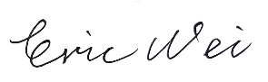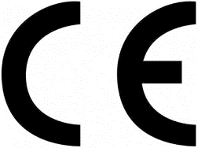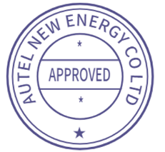

Eric Wei  
Product Safety Compliance Manager  
2022-09-20